Ryan Farruggia

CSC 28

Professor Mayer

24 February 2021

Quiz 1

1. **Ɐ** y **Ǝ** z **( y + z = 111.11 )** means “for all elements y, there exists an element z where their sum is equal to 111.11
2. S is the set of integers n where n is every even number between (inclusive) 33 and 3333.
3. Recursion in programming languages is using the solution set of smaller problems to solve a similarly larger problem through repetition or iteration.
4. In a sequence, there can be any set of numbers or elements that are ordered according to some set of rules or formulae. In a set, the indices/positions of elements does not flow according to anything. Repetition of elements is also commonly allowed in sets, whereas not allowed in sequences.
5. Continuous mathematics uses infinity and similar concepts that are not concretely countable by nature. Discrete mathematics uses any set of numbers that can be countably represented. An example for discrete mathematics would be phone numbers where it is very possible to count through every phone number in existence because they are finite.
6. **- ∈** means “in”, “includes” or “contains.”

* **⊇** means “is a superset of”
* **⊂** means “is a proper subset of”
* **∅** means “empty set”

1. A formula for the sequence an = 2, 9, 28, 65, 126 … ∞ would be: n3 + 1
2. 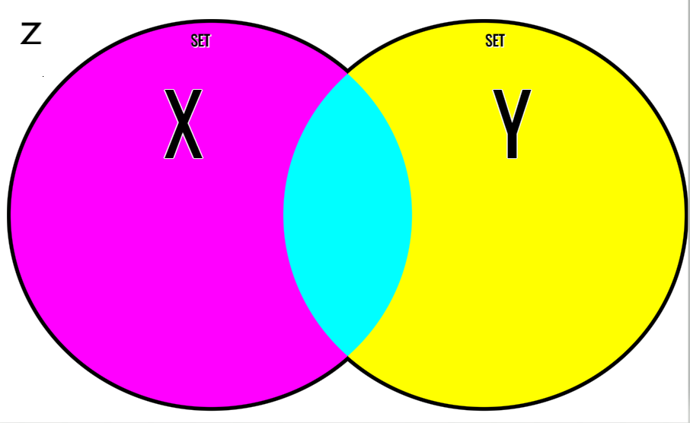
3. The nodes where the information is located and the lists containing the actual information. You would need an array or complementary parallel arrays to organize this properly in Java/C++.

|  |  |  |  |
| --- | --- | --- | --- |
| **P** | **Q** | **PQ** | **P⊕Q** |
| **0** | **0** | **1** | **0** |
| **0** | **1** | **1** | **1** |
| **1** | **0** | **0** | **1** |
| **1** | **1** | **1** | **0** |

1. Table shown:
2. A byte is a binary set consisting of bits. Memory is always accessed by byte because it’s far quicker and more efficient than by bit. Data is transferred between the CPU and memory via a data bus located in the motherboard. An aligned address is an arranged piece of memory that aids in ease-of-access when pertaining to information from the main memory.
3. There are 12 total outcomes for throwing a dice and a coin. The probability that a 4 shows on the dice and the coin flips to heads is 1/12.
4. Skip
5. Propositional logic is logic that deals with true/false statements and the relationship between two or more statements.
6. A power set is the set of all subsets some set **S**. The power set P(S) = {}, {6}, {1}, {6, 1}, {9}, {6, 9}, {1, 9}, {6, 1, 9}, {100}, {6, 100}, {1, 100}, {6, 1, 100}, {9, 100}, {6, 9, 100}, {1, 9, 100}, {6, 1, 9, 100}.